Comparison of svm, adaboost and nueral network

Bhargav Parsi (804945591)

# Adaboost

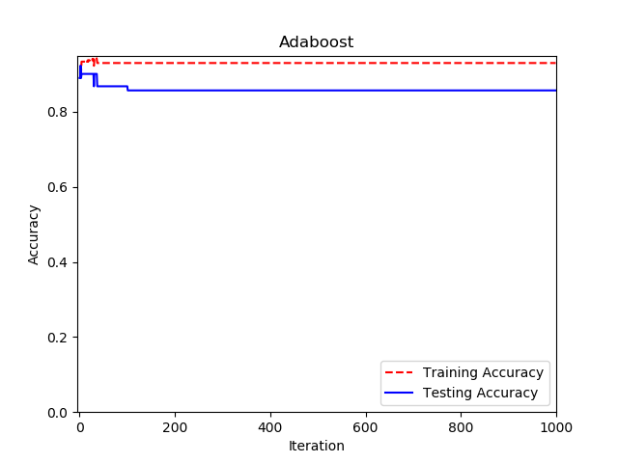

We can see that adaboost starts with a relatively high accuracy but as the number of iterations increase it tends to overfit the data. This can be see by the decrease in testing accuracy gradually.

# SVM

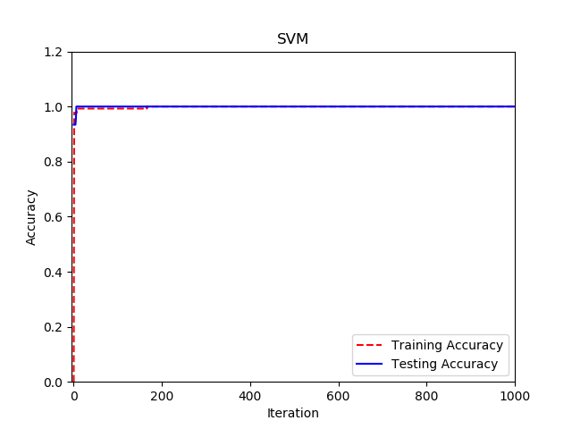

When compared with Adaboost, SVM give much better performance because it has a regularization parameter with it which penalizes the model if it overfits the data. Hence, we can see the steady increase of testing accuracy. Also we observe that the testing accuracy starts with a very low value and converges very fast to the optimal value.

# Nueral NEtwork

We can see that, both training and testing accuracies improve gradually. Also, it does not learn the model as fast as SVM learns, although it provides us with a descent accuracy at the end. We should also note that Nueral networks highly depend on the initialization of the parameters. For the given data set I found that using a random normal initialization with standard deviation = 0.3 works the best. They also depend in the activation function used. After a few experiments I found out that using sigmoid on both layers give better results than Relu.

Another important point about NN is that it works really well on Hugh data sets whereas SVM doesn’t.

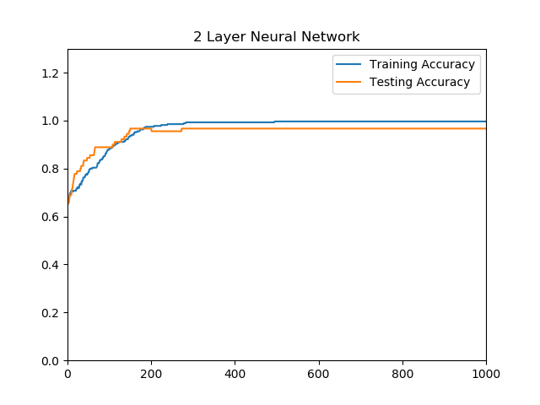

# Neural Network USing Tensorflow

We can see that the accuracy started with a pretty high value and it converges pretty fast ie., with 10 epochs. This is due to the Xavier initialization used and Adam optimizer.

